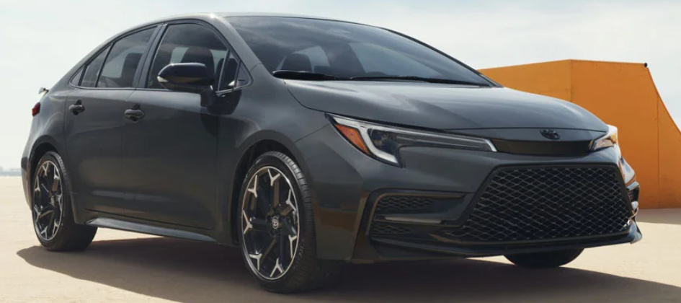

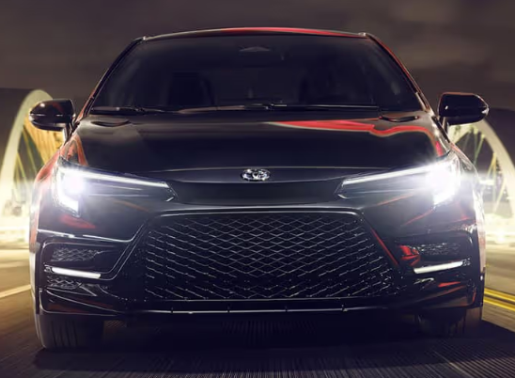

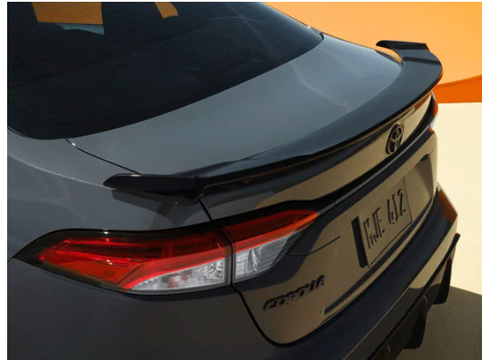

**Main specifications** for the **2025 Toyota Corolla Sedan**:

**🔧 Powertrain & Performance**

* **Engine**: 2.0 L inline‑4 gasoline (169 hp @ 6,600 rpm; 151 lb‑ft torque @ 4,400 rpm) **Transmission**: CVT (Dynamic-Shift CVT with 10-speed manual mode)
* **Drive Type**: Front-wheel drive

**⛽ Fuel Economy (EPA)**

* **Combined MPG**: ~35 mpg
* **City/Highway**: ~32/41 mpg

**📏 Dimensions & Capacity**

* **Length**: 182.5 in (4,636 mm)
* **Width**: 70.1 in (1,781 mm)
* **Height**: 56.5 in (1,435 mm)
* **Wheelbase**: 106.3 in (2,700 mm) 5
* **Curb Weight**: ~2,955 lb (1,340 kg)
* **Cargo Space**: ~13.1 cu ft (371 L)

**🛋 Interior & Tech**

* **Infotainment**: Standard 8″ touchscreen; available 10.5″ on higher trims
* **Connectivity**: Wireless Apple CarPlay & Android Auto (all trims)
* **Seating**: 5-passenger; cloth upholstery standard

**🛡 Safety & Driver‑Assist**

* **Toyota Safety Sense 3.0** standard – includes Pre-Collision System, Lane Departure Alert with Steering Assist, Adaptive Cruise Control (Full‑Speed DRCC), Automatic High Beams, Traffic Sign Assist, Blind Spot Monitor, Rear Cross Traffic Alert

**🏁 Suspension & Wheels**

* **Front/Rear Suspension**: Independent front suspension with stabilizer bar; rear torsion-beam
* **Wheels/Tires**: 16″ standard (205/55 R16); up to 18″ available on SE/FX/XSE

**📦 Warranty Coverage**

* **Basic**: 3 yr / 36,000 mi
* **Powertrain**: 5 yr / 60,000 mi
* **Hybrid Battery**: 10 yr / 150,000 mi (for hybrid trims)